**Building a Personalized Product Recommendation System based on User Preferences** using Flask.

**Problem Statement:**

**Develop a Flask application that recommends similar products based on user preferences for price, number of favorites, and number of reviews.**

This could be used by users looking for personalized product recommendations when shopping for baby products or gifts. You could provide recommendations based on criteria like budget, popularity, or high reviews.

Solution Plan :

* **Price**: Users may want products within a specific price range.
* **Favorites**: Popularity based on how many people favorited the product.
* **Number of Reviews**: Customer feedback can influence product recommendations.

The goal is to build an application where users input their preferences (e.g., price range, minimum reviews, popularity), and the system returns similar items from the dataset.

How we will do it ?

Step 1 : I m taking etsy baby items data set

Step 2 : importing the libraries.

Step 3: Reading the dataset

Step 4 : Converted listed_on to date and time format like firstly it was like and I made it to this 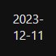. Only purpose of doing this was making the dataset more readable format so that it doesn’t throw error lately.

Step 5: Data cleaning and preoaration finding the missing values if your have some missing values caught and immediately fix this using .fillna function.

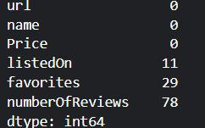

After cleaning we got

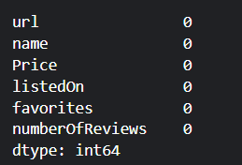

Step 6 : Performing Exploratory Data Analysis (EDA)

**Random Forest and Gradient Boosting** achieved perfect accuracy in this example.

**SVC** had slightly lower performance but still significant.

**Feature Importance** shows that favorites is the most influential feature.